Time - Duration
Have a go at estimating how long it would take to do the following things.
This is to get you thinking about different possible durations of time. It could be seconds, minutes, hours, days, weeks, months or even years!

- Walk a mile

- Brush your teeth

- Sleep for a night

- Make a cup of tea

- Run a bath

- Wash a car

- Hang out a full basket of washing

- Watch a film

- Read an entire book

- Bake a cake

- Run 100m

- Walk from Galashiels to Earlston

- For something to grow from seed into a small plant.

- For a Mum to grow a baby.

- For an apple tree to grow from a sapling to a tree producing apples.

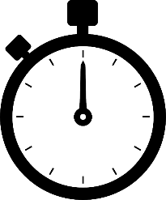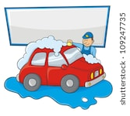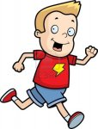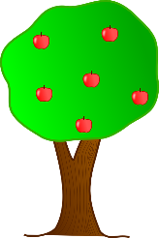

This Photo by Unknown Author is licensed under CC BY-NC-ND

