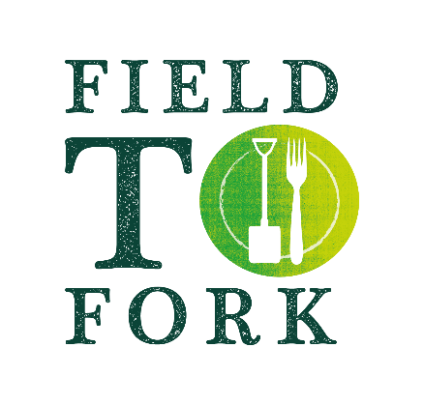
Spud-u-like!
Are you growing your own potatoes
at home – or perhaps you were
growing them at school before
everything closed?

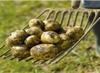
Potatoes are an important crop at the Hirsel. They grow well in the deep, fertile soils along the River Tweed. In some parts of the UK, this season’s potatoes are already being harvested but our potatoes will not be lifted until late summer/autumn. Potatoes are good to eat being full of energy and vitamin C! There are lots of ways to cook and eat them – the unhealthy bit can be what you add to them! What is your favourite?
Activities:
- Story of potato growing – watch the video showing potato journey from field to fork.
https://www.youtube.com/watch?v=vxrcXF_k9Wg
Can you now draw a cartoon strip to tell the story?
- The potato harvester – for a picture to colour see https://growyourownpotatoes.org.uk/media/1216/gyop-colouring-sheets.pdf or attached PDF, or draw your own picture or make model of the machine from lego or junk.
- Be a soil scientist – get down and dirty and find out what’s beneath our feet.
- Mud Art – what can you create from some soil and water?
- 2 recipes to try – because potatoes are so good: Stuffed Baked Potatoes and New Potato Salad.
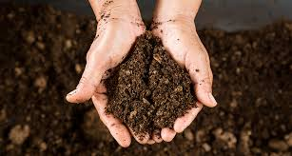
Be a soil scientist
To grow crops such as potatoes, healthy soil is very important. Soils are not all the same, even in the same field. Farmers need to know about the soil in their fields and how to look after it.
This video called ‘Soil is Sensational’ tells you more: http://www.farmingismagic.co.uk/films/soil-is-sensational/
Try examining some of your soil. Do ask before digging!
What to do:
- Dig a large spadeful of soil from a suitable place in your garden and spread it out on a plastic sheet or similar.
- Carefully examine your soil. Do you see any roots (they can be very fine), bits of dead plants, stones, creatures?
- Pick up a handful of soil – in it will be millions of tiny bacteria and fungi that you cannot see – in fact in a handful of healthy soil there are more living things than people on the earth – wow!
- Have you found any worms? Do they all look the same (there are many species of worms in our soils)? They do amazing work breaking up the soil and any plant material. Look in the hole your soil came out of. Can you see any worm channels? They help air, water and roots to travel through the soil.
http://www.farmingismagic.co.uk/films/wonder-of-worms/
- Find out what kind of soil it is by doing the Gritty Sticky Test – pick up a small bit of soil. Rub it between your fingers, does it feel gritty or sticky? Put it to your ear, rub it again, can you hear it?
If it feels sticky and makes no noise, it is a clay soil, if it feels gritty and makes a noise it is a sandy soil. Most soils are somewhere in between!
Mud Art
Make some mud paint and paint a picture or make a mud face.
To make mud paint:
Mix some of your soil with a little water so it is a consistency you can paint with. Use your fingers or a paint brush to paint a picture. What other ingredients could you add to alter the colour? You could even make some stamps out of potatoes.
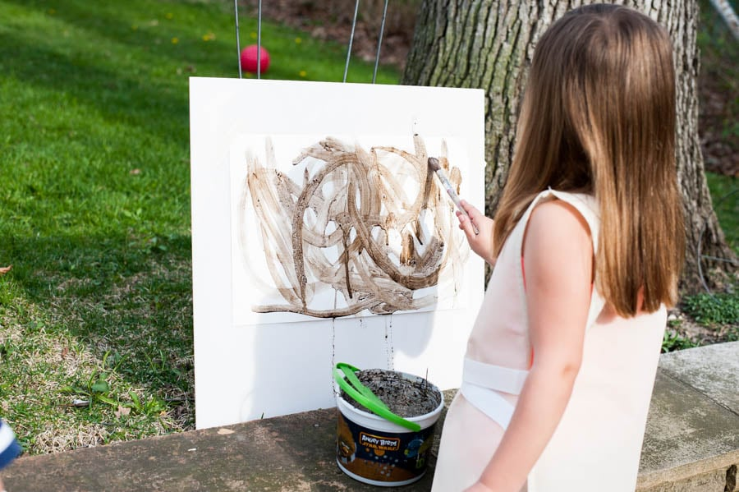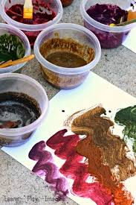

To make mud faces:
This works best if your soil is clayish. You might need to add some water to make it stick together like clay – but not sloppy like your paint.
Take a lumps of this mud and press it onto a tree trunk, fence or flat on a paving slab.
Find other natural items to add features to your face – eyes, mouth, nose, hair and so on.
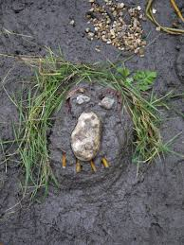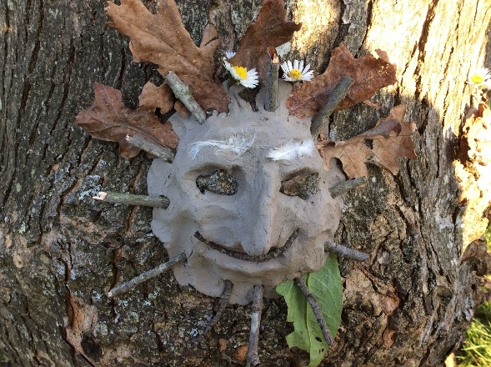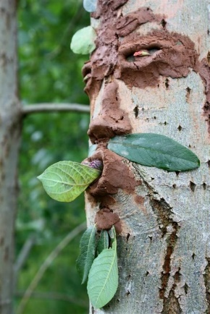

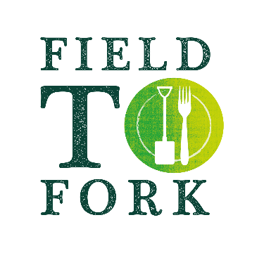
Stuffed Baked Potatoes

1 baking potato
2 tbsp low fat cottage cheese
2 tbsp low fat milk
1 tbsp toasted sunflower kernels
1 tbsp red bell pepper chopped
1 tbsp spring onions, chopped
1 tbsp sweetcorn/kidney beans
2 tbsp cheddar cheese grated
2 cherry tomatoes halved

Pierce potato with a fork and bake in oven 160C for about an hour until soft. Leave to cool slightly.
Halve and scoop out potato leaving 1 cm shell
In a bowl mash the potato pulp.
Mix in the cottage cheese and enough milk for a moist but firm consistency.
Add in sunflower seeds, pepper, spring onions, sweetcorn/
beans and half the cheddar cheese and mix thoroughly.
Mound into potato shells, dividing equally. Sprinkle with remaining cheese.
Replace in oven for 20 minutes or microwave on HIGH for 2 minutes to melt cheese and heat potato through thoroughly.
Garnish with tomato halves.

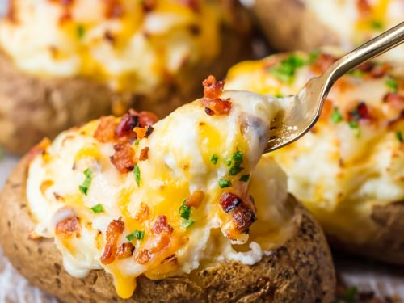
New Potato Salad

900g small new potatoes, scrubbed
½ firm cucumber, diced
3 spring onions, finely sliced
1 red pepper, chopped
½ can kidney beans
2 tablespoons sunflower seeds

Dressing: 3 mayonnaise
5 tablespoons low fat natural yogurt
1 teaspoon lemon juice

Cook potatoes in pan of boiling water until just tender (about 10 minutes). Drain and return to pan. Set over low heat and shake for a few minutes to evaporate moisture. Transfer to mixing bowl and allow to cool completely.

Mix together dressing ingredients and add to potatoes along with chopped vegetables, beans and seeds. Mix together gently. Transfer to serving dish.

