Home Learning Grid Week Beginning 15.06.20
Numeracy and Math | Literacy | Health and Wellbeing | Other ideas
* Continue to practice our counting skills, using the grid to keep track of your progress. | Retell a story  Re-write your favourite story in your own words. You can choose how to lay it out: a story of written text, a comic book strip, a play with puppets (you could record it!) and so on. | Remember to complete the June Kindness Calendar | Paint some pebbles and turn them into colourful creatures!
SUMDOG Challenges are available for the week. They will finish at 2pm on Friday. | Invent a story!  Grab 5 toys or objects from around the house. Make up a story about the objects. | Be a mini Masterchef!  Help whoever does the cooking in your family to make a recipe or meal you can enjoy together. | Have some quiet time away from a screen. Draw, colour in or have some time outside for a walk.
When outside for a walk, take a bag to collect some of the different things you find. Sort it into a table (it could look like this):  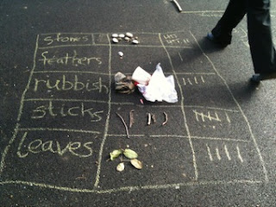  What was the most popular thing you found? | Read your favourite story with someone at home (if it is a large story, pick one of your favourite parts). When complete, ask them 3 questions about the story. | Build an obstacle course and challenge someone at home. Who can go round the fastest? Try to include running, hopping, jumping, zig zags and different heights. | Can you upcycle some packaging, cartons, yoghurt pots or tin cans into something useful at home? It could be a pencil pot, a plant pot or a home for some toys.
Keep a schedule of your day. Note down the time and what you did for each event of the day e.g.,  8:00 am – got out of bed  8:40 am – had cereal and a cup of tea  9:00 am – played with the cat  and so on. | Nature scrap book  When out collecting things for the other activities. Record the things you see by drawing a picture of them and writing some descriptive words. This will record your journey. You could even glue some things in that you found. | Keep a diary for a week. Include the things you have done, how you felt and you might want to add illustrations. | When outside, gather twigs, leaves, pebbles and other materials to create a life size picture of you!

