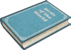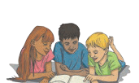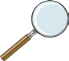

**My Home Reading Record**

**visit twinkl.com**

**Week Beginning**

**Book Title and Author**

**Who Did I Read With?**

**Where Did I Read?**

**Monday**

Why do you think the author wrote this book?

**Tuesday**

What have you read today for learning? For pleasure? For need?

**Wednesday**

Write a wonderful word from your reading today.

**Thursday**

What have you read today for learning? For pleasure? For need?

**Friday**

If you could ask the author a question, what would it be?

**Saturday**

Write a wonderful word from your reading today.

**Sunday**

What does your book make you want to read next?