Literacy  P7 Home Learning Plan WB: 18.5.20 | Numeracy/Maths | Health & Wellbeing | Other Areas
Reading:  Disgusting Digestion: read pgs 134-157  Fing: read pgs 165-183  Eerie Elementary: read pgs 168-end  Alex Rider: read pgs 127-146 | Log onto your Sumdog and study ladder accounts. I have set some challenges for you. Practise your maths skills.  I will be able to see your activity and progress. | P.E :  How many laps of your garden or street can you walk/run in 10 minutes?  Do this every day – can you beat your record? | Expressive Arts:  Look at the Andy Warhol pictures in your pack of endangered species.  - What questions would you ask these animals?  - Can you draw an animal of your choice using shading to add definition?
Reading Activities:  - Make a timeline of important events in the text .  - Make a list of five titles that you think would make a better name for your text.  - Draw a map of the journey the main character took in the text  - Write 3 questions you would like to ask the main character in your text. | Complete Time sheets included in your pack. | Social/Emotional: Watch a movie of your choice. Pick a character and complete the emotion works grid included in your pack. Think about what they are feeling. | Topic:  Look at the Animals topic plan.  Choose some of these activities to do.
 | Using whatever strategy works best for you; calculate the mixed operation sums below. Choose a colour to complete (red is the easiest) | Food Health: Think about sea food.  Why is it good for your body? What does it do for your heart, eyes, joints, brain and skin? What vitamins are in fish?  Talk to an adult, research or look on food packaging to find out. | Science/Technology:  Can you build a habitat for an animal? It can be for in your garden or you could use a shoe box or junk to make a model of a habitat.  Take a picture of it and post it in the blog or on teams.
Reading: Log onto EPIC Reading using the class code: itm5966  EPIC is only accessible during school hours.  If using a tablet or phone, ensure you click ‘Have an account? Sign In’ at the bottom and not on ‘Parents’. Then, input your class code under ‘Student Log in.’  Read pages 4-15 of “Platypus: A Century-long Mystery” and complete the following activities over the course of the week:  1.Use Metalinguistics strategies to work out the meaning of the following words:  bill (p5) taxidermists (p8) captivity (p15)  2. Read pages 16-29 and use what you’ve read to create a detailed Visualiser of a platypus. You can include quotes and remember to add page numbers.  3. Using what you have read, create a quiz about the platypus for someone in your house to answer. You could make it TRUE/FALSE style if you wish! | - 83+35 - 89-21 - 65/3 - 97-45 - 27x6 - 98x5 - 245+132 - 34x2 - 47/3 - 65/4 - 98-67 - 47x7 - 35x9 - 198+67 - 36x6 - 764x7 - 984x5 - 543+362 - 974-347 - 627+214 - 643x5 - 974/6 - 248+225 - 868/6 - 864-203 - 345x4 - 874x5 - 456-256 - 1632-965 - 832/3 - 5674x8 - 8753-6432 - 5672/8 - 7531-3213 - 9752/3 - 4321+65432 - 8753x7 - 6214+9864 - 5642/4 - 4135/3 - 7233-6321 - 5631x4 - 6272-6754 - 7253/6 - 7283x9 | Outdoor Learning: See how many animals you can spot in your area every day.  I currently have a pheasant living in my garden, what’s the strangest thing you see?  Can you spot a squirrel? | RME: Name as many religious festivals you can think of. What are they and who celebrates them?  Can out find any facts about any new ones you didn’t list.
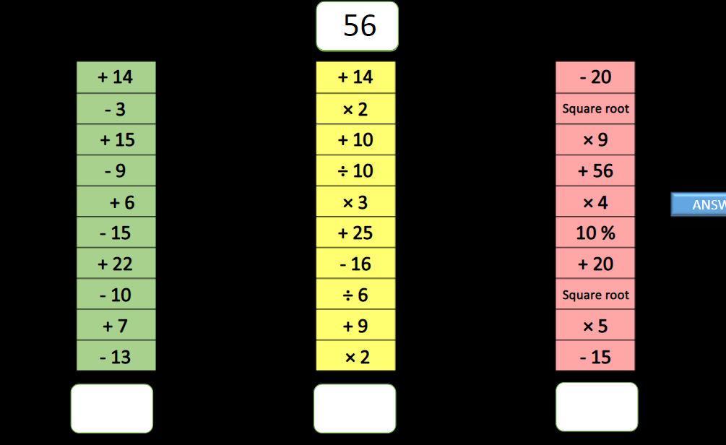
Can you complete this ski run….

Writing: Use the story starters in your pack to write a story.
Comprehension:
Complete comprehension tasks in the pack.
Log onto study ladder, sumdog and edshed and complete some comprehension and spelling tasks
Spelling: words written on blog page. Practise these daily using your spelling grid.

