Numeracy | Literacy | Health and Wellbeing
Adding 9 and Adding 11  This is something we were working on before we finished school. I would like you to create your own questions or ask an adult to for you. When adding 9 we spoke about 9 being close to 10. We said it’s easier to add 10 and then take away that 1 you added on.  When adding 11 we said, it’s also close to 10. So add on 10 first then add on 1 afterwards.  Here are some numbers for you to add on 9 and 11 to.  12, 15, 21, 26, 34, 54, 29, 10, 5, 38  You can write these in your jotter or you could use your individual Numeracy page on teams. | Corona Virus Cookbook  I thought we could collect lots of recipes we have been enjoying and put them together to create a cookbook.  Write a set of instructions for a recipe you have made at home or enjoyed over the last few weeks. This could be a snack idea or a meal, something that you enjoy to eat with your family. We have written instructions together in class before, remember you will need to include ingredients, equipment and method (instruction on how you make it).  Think about what makes a good sentence, there are a few things we always talk about in class to help our writing make sense and sound exciting.  You could type up your recipe, write it in your jotter or create a poster it is entirely up to you. You can take a picture of your recipe and upload it to the school blog or you can also upload it to you individual literacy page on our teams account. | Emotion Works  We talk a lot about our emotions in class and we know this is important to do.  I would like you to have a go at making your own cog. You can write down any emotions that you are feeling just now.  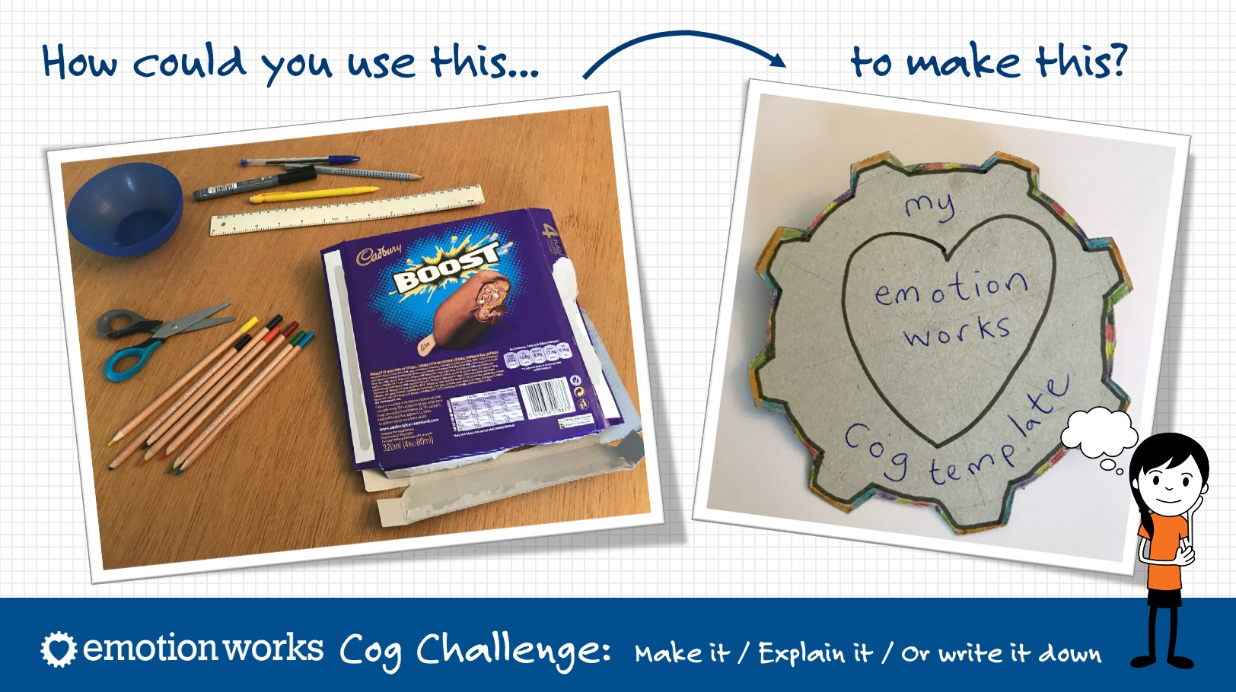
Multiplication tables  I gave you some multiplication dot to dots to do in your home learning pack. I have attached a link for you to practice these.  https://www.topmarks.co.uk/maths-games/hit-the-button | Spelling  This week your spelling words all have the oi sound, we have done this sound before but I would like to recap on this.  Join , coin, voice, joint, oil, tinfoil, coil, soil, boil, toil  Use the spelling grid to choose an activity to do, you can do as many activities as you like each day. | Food Diary  This week I would like you to keep a food diary. Use the jotter I have given you to record what you have eaten and drank over the course of the week.
SUMDOG  I have set you all a new challenge on Sumdog. This will last for the week. Remember to take your time and its about answering questions correctly rather than seeing how many questions you can get through in your session.  If you have forgotten your username and password then please let me know and can give it to you. | Reading  Choose a book you have at home and take some time do some reading either by alone or with someone at home.  I have attached a link to Fantastic Mr Fox the audio book that you can access and read along side as the words appear on the screen. This will maybe take you the whole week or longer to read.  https://www.youtube.com/watch?v=nJofxwa5bMo | Keep fit and Healthy  Try and do Joe Wicks workout everyday, I have attached the link below to his workouts for you to enjoy. If you can’t access them then make sure you are getting out and about safely getting lots of fresh air.  https://www.youtube.com/watch?v=2iDqBO34ieA

