Literacy  P7 Home Learning Plan WB: 25.5.20 | Numeracy/Maths | Health & Wellbeing | Other Areas
Reading:  Disgusting Digestion: read pgs 157-173  Fing: read pgs 183-203  Eerie Elementary: choose a book of your choice to read. You may like to use the Epic app or website to find a new book.  Alex Rider: read pgs 146-175 | Log onto your Sumdog and study ladder accounts. I have set some challenges for you. Practise your maths skills.  I will be able to see your activity and progress. | P.E: Look on youtube for The New Zealand Rugby Team Haka.  - Look at the movements they make  - What are their facial expressions like?  - Recreate or make up your own haka | 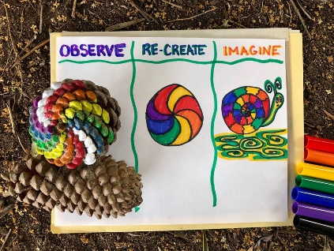  Expressive Arts: Pick an object like a pine cone or a leaf. Observes it (look at it), recreate it and imagine it into something else. Post your creations to the blog or teams.  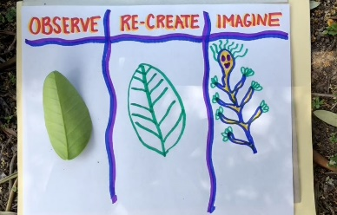
Reading Activities:  - Write 3 questions you would like to ask the main character in your text.  - Write what you think of the main character.  - Decide what you would change about the text and write two to three paragraphs. | Find the fraction of the amount: (remember to divide by the number on the bottom of the fraction then multiply by the top of the fraction)  Yellow group:  - ¼ of 20 2. ¼ of 40 3. ¼ of 120  4. ¼ of 36 5. ½ of 100 6. 1/10 of 100 7. 1/5 of 100 8. 1/6 of 180  9. ½ of 24 10. 1/6 of 24  Blue and Green group:  - 1/10 of 100 2. 1/5 of 100  3. 1/6 of 180 4. 2/6 of 180  5. 3/5 of 25 6. 2/3 of 18  7. 4/7 of 49 8. 5/6 of 36  9. 3/1 of 55 10. 1/3 of 45 | Social/Emotional: Think about emotion works.  Watch https://www.youtube.com/watch?v=  8AGgbIQyqR8  - Can you name the different emotions shown throughout the short?  - What emotions is she feeling in the photos at the beginning?  - What behaviour does she use to express her feelings?  - What regulation strategy does she use? | Languages: Play the French game included in your pack.  Have a go at logging into the duolingo app to practise your languages. (Instructions and class codes on the blog and in teams)
Reading: Log onto EPIC Reading using the class code: itm5966  EPIC is only accessible during school hours.  If using a tablet or phone, ensure you click ‘Have an account? Sign In’ at the bottom and not on ‘Parents’. Then, input your class code under ‘Student Log in.’  Read pages 1-20 of The Vast Wonder of The World:  - Write 5 comprehension questions about the text. Start your questions with Who, What, Where, Why, When? | Using the strategies taught during Maths, calculate the sums below.  Choose a spice level or do them all! Show your working in your jotter.  Mild! Spicy! Hot!  45÷9 145÷5 1547÷8  87+65 458+125 7854+4575  96-41 987+231 9874-6321  54x5 745x6 8745x4  101-23 987-705 7452-6521  65x4 754x5 8745x7  75+96 320+458 5456+6321  84÷6 862÷6 8745÷9 | Food: Think about where your food comes from.  - Pick a food product  - Find out about all the places it is grown or made  - How many miles is that from where you live?  If often tells you on fruit and packaging where the product is from. | Science/Technology:  SPAGHETTI BRIDGES  Can you build a spaghetti bridge that's strong enough to hold a bag of sugar?  Video available at : www.jamesdysonfoundation.co.uk/resources
 | 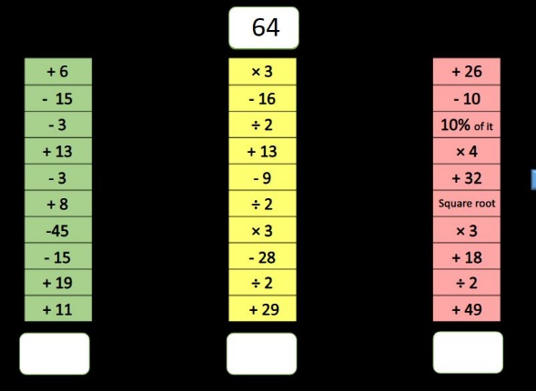 | Odd Dog Out  - Look up the Odd Dog Out story on Youtube. What is the main idea of the book?  - Draw your own Odd Dog Out - Watch, Draw with Rob Video 2 -  https://www.youtube.com/watch?  v=pPeyVoZyBzY | RME: Influential Figures.  Think about a famous person.  Research information about them.  - How do they influence people?  - Do they support any charities?  - What do they do to influence people positively?
Writing: Write a letter to the academy to tell them all about yourself.  You might want to use some of these ideas for the paragraphs:  - What you like and don’t like about school?  - What you are looking forward to at the academy?  - What will you miss about primary school?  - What subjects you like/don’t like and why?  - Are there any things you might need some help with?  - What are you worried about for the academy? | Complete Harry Potter timetable activity. | Outdoor Learning:  Collect some twigs and stones.  Make a picture out of these.  Upload the picture to the blog or teams page under #NoFilter | Topic- Biomes:  A biome is a natural place that makes a habitat like a forest.  There are some  videos about this on the bbc bitesize daily on iplayer. (find further information on the sheets included in your pack  Describe/find extra information about the following biomes, what makes them different to other biomes:  Tundra –  Desert-  Tropical rainforest –  Savanna-  Temperate Forest-  Grass Land –  Jungle -
Log onto study ladder, sumdog and edshed and complete some comprehension and spelling tasks
Spelling: words written on blog page. Practise these daily using your spelling grid.

