Literacy  P7 Home Learning Plan WB: 15.6.20 | Numeracy/Maths | Health & Wellbeing | Other Areas
Reading:  Disgusting Digestion: choose a book of your choice to read. You may like to use the Epic app or website to find a new book.  Fing: read pgs 245-end  Eerie Elementary: choose a book of your choice to read. You may like to use the Epic app or website to find a new book.  Alex Rider: read pgs 248-286 | Log onto your Sumdog and study ladder accounts. I have set some challenges for you. Practise your maths skills.  I will be able to see your activity and progress. | P.E:  Have a go at some yoga-  There are pictures of some different moves in your pack. | Expressive Arts:  Check out #DrawwithRob on youtube.  Can you draw a racing car, peacock or even sonic the hedgehog!
Reading Activities:  - Re-tell an event in the text from another character’s point of view.  - Write a letter as a character in the text to another character in the text, a new invented character or a real-life character.  - If finished reading your book – make your own blurb for the book. | Using the strategies taught during Maths, calculate the sums below.  Choose a spice level or do them all! Show your working in your jotter.  Mild! Spicy! Hot!  15+62 154+625 4851+6251  85-35 625-268 6541-2541  54x6 124x9 3248x3  28÷4 456÷6 4582÷3  35÷6 354÷3 2145÷9  52+36 321+586 1258+6541  85-39 258-103 3005-4210  53x8 268x8 3654x8  65+23 958+562 9625+1458  154+65 2358+658 62587+1245 | 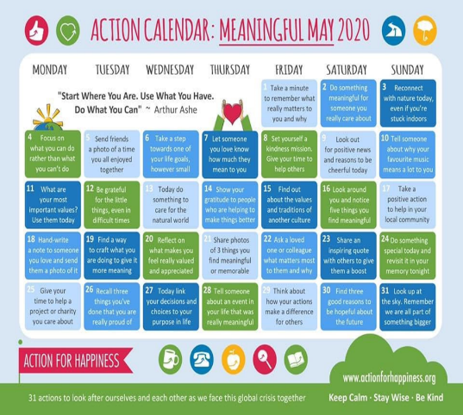  Try some of these activities. | Languages: Can you complete the French conversations sheet included in your pack – try having a conversation in French with your family or even try it in Spanish.  Have a go at logging into the duolingo app to practise your languages. (Instructions and class codes on the blog and in teams)
Reading: Log onto EPIC Reading using the class code: itm5966  EPIC is only accessible during school hours.  If using a tablet or phone, ensure you click ‘Have an account? Sign In’ at the bottom and not on ‘Parents’. Then, input your class code under ‘Student Log in.’  Read Soldier Bear Chapter 1- 5  Answer these questions:  1. On page 1 what clues are there that it was hot? (use quotes form the text)  2. What does it mean by ‘the bear fell back on its haunches’?  3. What started the second world war?  4. Which country did Peter and Stanislav escape to?  5. What was the soldiers first task in the British camp after training?  6. What did the boy leave with after finding the bear?  7. Which countries border Syria? | Answer these maths questions:  1. What number is less than 150 less than 2250?  2. What is 30 multiplied by 30?  3. A television programme starts at 9.38 and ends at 10.05  How long does it last?  4. Increase £1.50p by 50 percent  5. What is the square root of 144?  6. Which two single digits have a product of 63?  7. Imagine a cuboid. How many vertices does it have?  8. Write the fraction sixteen-sixty fourths as simply as possible.  9. Round nought point three four eight to two decimal places.  10. What is 20 percent of 700? | Emotions:  Write or draw a happy memory. Next time you get worried or upset you can look at it and be reminded of the happy times. There are lots of chances to create new positive memories so these can be added to previous ones. | Science/Technology:  Try to build a marble run from a cereal box. Use the sheet in your pack to help you.
 |  | Advertising:  Think about food products what makes you want to buy them apart from ‘they taste good’. Companies use brands, logos and slogans to advertise their products. Like McDonalds – ‘I’m Loving it’ is a slogan they use.  Complete the advertising and consumer sheet in your pack. | Music:  Learn some body percussion with Ollie Tumner on Youtube. Why don’t you upload a video of you doing this onto teams or send me an email.  Get the whole family involved.
 |  | Outdoor Learning:  Take part in one of the scavenger hunts included in your pack.  Why not try the nature one this week. | Topic-  Complete some of the topic tasks in your pack or from the last pack.  Research some different climates and what types of animal can be found in each? What is special about this type of climate – is it hot, cold…?
Complete all the yearbook and assembly activities in your pack.  Log onto study ladder, sumdog and edshed and complete some comprehension and spelling tasks  Spelling: words written on blog page. Practise these daily using your spelling grid. | Write these decimal numbers as a fraction:  - 0.5 2. 0.3 3. 0.75 4. 0.40 5. 0.8  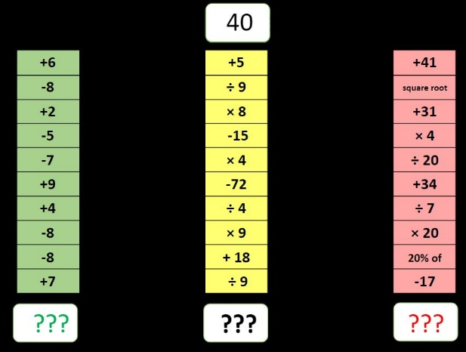  6. 0.9 7. 1.1 8. 3.5 9. 8.6 10. 8.25 |  | Topic –  To learn some more cool stuff about our topic you could watch one of these programmes on youtube, netflix or iplayer.  - Blue Planet  - Deadly 60  - Our Planet  - Planet Earth  - There are also some cool programmes on disney + all about different animals.  - Steve Backshall is live on youtube and facebook every Wednesday to teach you about animals etc…  Let me know what you learn.
Writing:  Write instruction of how to create the perfect tiktok?  You might want to pick a specific tiktok or tiktok dance to add lots of detail to your writing.  You don’t have to write about a tiktok if you ould prefer to do instruction on how to make a youtube video or how to play a game that’s fine too. | 