Literacy  P7 Home Learning Plan WB: 01.6.20 | Numeracy/Maths | Health & Wellbeing | Other Areas
Reading:  Disgusting Digestion: read pgs 173-190  Fing: read pgs 203-226  Eerie Elementary: choose a book of your choice to read. You may like to use the Epic app or website to find a new book.  Alex Rider: read pgs 179-209 | Log onto your Sumdog and study ladder accounts. I have set some challenges for you. Practise your maths skills.  I will be able to see your activity and progress. | P.E:  Have a go at one of Oti Mabuse home dance along videos on youtube.  Why not get the whole family involved. | Expressive Arts:  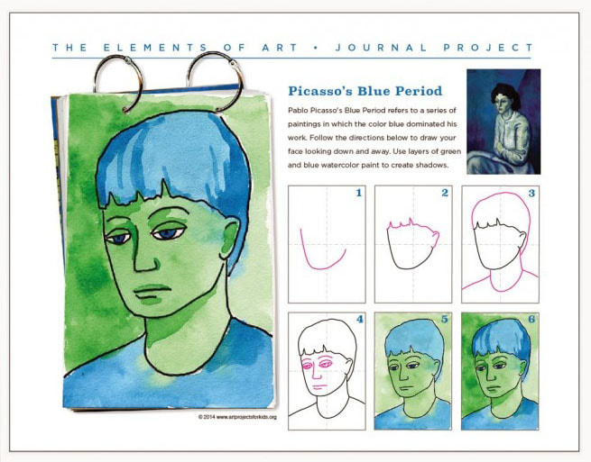
 | Calculate the change:  Yellow group:  I have £5 and I spend;  - £2.30 2. £4.62 3. £1.25  - £3.44 5. £0.77  I have £10 and I spend;  - £7.21 2. £4.36 3. £8.96  - £4.12 5. £6.96  Blue and Green group:  I have £15 and spend:  - £10.21 2. £5.58 3. £7.89  - £11.65 5. £8.45  I have £20 and spend:  - £15.89 2. £16.55 3. £17.08  - £16.30 5. £19.03 | Social/Emotional:  Talk about how you are feeling.  What are you grateful for?
 |  | 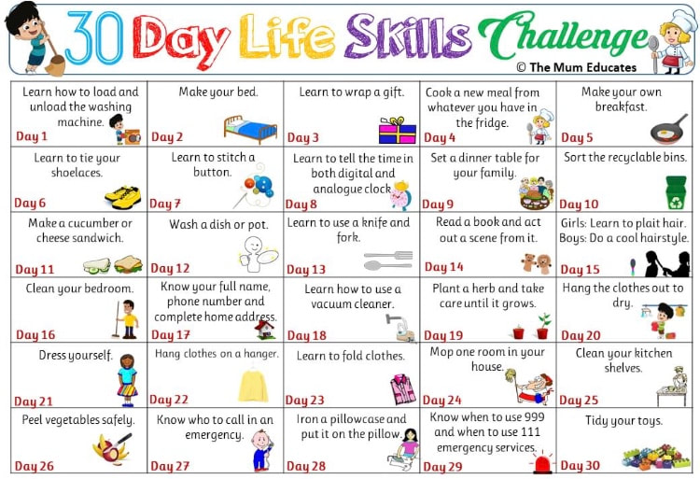
Reading Activities:  - Draw a picture of a character in your text and write down all the words the author used to describe them.  - Find 3 examples where the writer uses interesting words. Copy them out and explain why you like them. Or more than 3 examples?  - Choose a character in the text and write a diary for one day in their life. | Using the strategies taught during Maths, calculate the sums below.  Choose a spice level or do them all! Show your working in your jotter.  Mild! Spicy! Hot!  79÷9 201÷5 5632÷8  102+65 458+125 8643+4575  121-41 523+231 8541-6321  82x5 723x6 2564x4  96-23 856-705 9563-6521  62x4 236x5 1235x7  98+96 320+965 6354+6321  75÷6 953÷6 3541÷9 | Food:  Did you know you could make your own creamy butter in about 10 minutes just from double cream?  Why not try the recipe below.  I’ve also attached a recipe for bread making to go with your butter – it might be more tricky to get bread flour and yeast right now but if you can – try that recipe too. | Languages: Play the French weather game included in your pack.  Have a go at logging into the duolingo app to practise your languages. (Instructions and class codes on the blog and in teams)
Reading: Log onto EPIC Reading using the class code: itm5966  EPIC is only accessible during school hours.  If using a tablet or phone, ensure you click ‘Have an account? Sign In’ at the bottom and not on ‘Parents’. Then, input your class code under ‘Student Log in.’  Read pages 20-end of The Vast Wonder of The World:  - Review this book use the sheet in the pack to help you. | 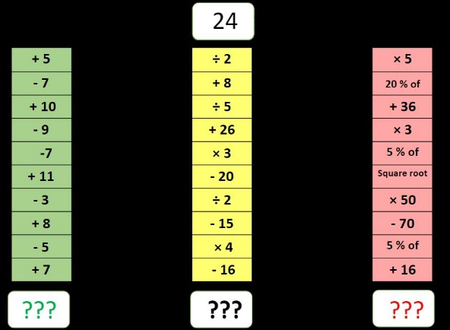 | Fun activity:  How many pairs of socks can you aim into a basket, washing machine or tub in 1 minute?  Try to beat your score. | Science/Technology:  Check out maddiemoate on youtube.  Try to make one of the things from her videos.
Writing:  Generationlockdown.co.uk competition  write piece of writing about what life has been like in lockdown and during the coronavirus.  This could be a personal experience, a poem, or a creative story. All of you will have had a unique experience that is only yours, and only you can capture in words.  Your entry should be 700 words or under and you should submit in your age category.  You can send your work to me to submit or submit it through this website. | Complete convert the time sheets. | Outdoor Learning:  Take part in one of the scavenger hunts included in your pack. | Topic:  Go to reefrelief on youtube.  Check out what they are doing and see what you can find out about ocean life.  Write down some interesting facts.
Topic-
Answer these questions, you might have to ask an adult for help or research the answers.
- What is the equator?
- Name 3 countries the equator ‘runs’ through?
- What is the Northern Hemisphere?
- Name 3 continents in the Northern Hemisphere?
- Name 5 countries in the Northern Hemisphere?
- Name 5 countries in the Southern Hemisphere?
- What are the tropics called? What are the tropics?
Comprehension:
There are comprehension sheets included in your pack.
Have a go at some of them.
Log onto study ladder, sumdog and edshed and complete some comprehension and spelling tasks
Spelling: words written on blog page. Practise these daily using your spelling grid.

