Literacy  P7 Home Learning Plan WB: 08.6.20 | Numeracy/Maths | Health & Wellbeing | Other Areas
Reading:  Disgusting Digestion: read pgs 190-end  Fing: read pgs 226-245  Eerie Elementary: choose a book of your choice to read. You may like to use the Epic app or website to find a new book.  Alex Rider: read pgs 209-248 | Log onto your Sumdog and study ladder accounts. I have set some challenges for you. Practise your maths skills.  I will be able to see your activity and progress. | P.E:  Use the circuit cards in your pack to create a circuit.  Try out your circuit for 20 mins – work for 30 seconds and rest for 30 seconds.  - How could you make it easier?  - How could you make it harder? | Expressive Arts:  RSPB art competition  Head to the link below for details. The competition is open till the 28th August 2020 so plenty time to think about an entry. Entries are to be emailed to competitions@rspb.org.uk  Task  -Create a piece of art inspired by nature – let your imagination run WILD! There are 2 categories to choose from this year – REAL LIFE – entries using the more traditional approach of paints, pastels, acrylics, pens or pencil. And our new GO WILD category – for those of you who want to ‘go wild’ in every sense of the word. To enter this category, experiment with textiles, sculpture, recycled and eco-friendly materials, collages – anything goes!
 | Write these fractions as decimals:  Eg. 1/5=0.20  - ½  - ¼  - 1/5  - 1/10  - 75/100  - 2/5  - 2/4  - 50/100  - 3/5  - 8/10 | Meaningful May:  "Take a step towards one of your life goals, however small". Do you want to learn something new or do you enjoy a particular area of school that you want to do more of? Have a think and see if you can make a start. I've always wanted to knit but didn't have the time to learn.
Emotional:
Sometimes we just need to imagine ourselves being somewhere else. I would be sitting having a picnic at the side of a loch looking down into the valley, surrounded by hills, forests and the sound of birds. What would your calm picture look like?
Reading Activities:  - Write down any new words you have seen in your text, look up their definition.  - Draw a picture of your favourite part of the text.  - Write a description of a character in your text. | Using the strategies taught during Maths, calculate the sums below.  Choose a spice level or do them all! Show your working in your jotter.  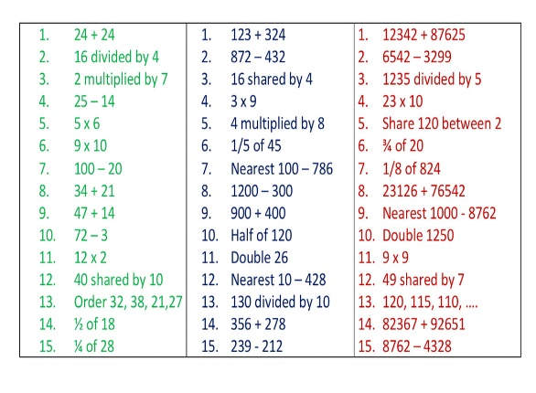 | Fun activity:  Reaction Time  Relay Running  (sheet included in pack) | Languages: Play French snakes and ladders (in your pack)  Have a go at logging into the duolingo app to practise your languages. (Instructions and class codes on the blog and in teams)
Reading: Log onto EPIC Reading using the class code: itm5966  EPIC is only accessible during school hours.  If using a tablet or phone, ensure you click ‘Have an account? Sign In’ at the bottom and not on ‘Parents’. Then, input your class code under ‘Student Log in.’  Read Rags: Hero Dog of WW1  - Complete the quiz about this book | 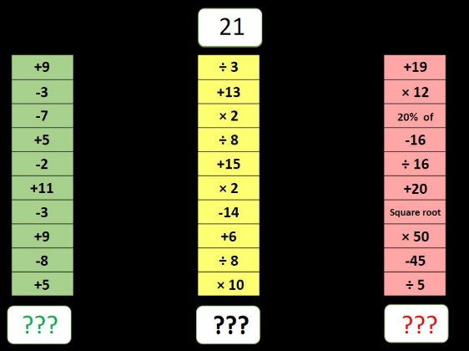 | Outdoor Learning:  Take part in one of the scavenger hunts included in your pack.  Why not try the bird one this week. | Science/Technology:  Look at the sheet in your pack with 4 technology projects.  Try one of these out.  Remember to set pictures of your results to the team, email me or post in teams.
Writing:  Write our P7 memories and send them to me or post in teams.  Think about  - What you enjoyed this year  - Favourite subject  - Favourite memory  - Favourite trip  - Best moment of Robinwood  - Memorable moments  - What you have achieved this year  - What you are looking forward to  - What you are going to miss  Remember to write why? Not just this is…. Use VCOP to make it a great piece of writing. | Complete London Eye timetable sheet. |  | Music:  Watch Myleenes Music Klass on youtube.  Check out her video The one where we show where all music came from.
Topic-
Complete some of the topic tasks in your pack or from the last pack.

Research some different animals that live in the rainforest.
Are any of them endangered?
Daily News:
Complete the daily news task attached.
Log onto study ladder, sumdog and edshed and complete some comprehension and spelling tasks
Spelling: words written on blog page. Practise these daily using your spelling grid.

