Literacy  P7 Home Learning Plan WB: 22.6.20 | Numeracy/Maths | Health & Wellbeing | Other Areas
Reading:  Disgusting Digestion, Fing and Eerie Elementary: Choose a book of your choice to read. You may like to use the Epic app or website to find a new book.  Alex Rider: read to the ned of your book (if possible) | Log onto your Sumdog and study ladder accounts. I have set some challenges for you. Practise your maths skills.  I will be able to see your activity and progress. | P.E:  Try another Joe Wicks work out on youtube.  Get the whole family involved. | Expressive Arts:  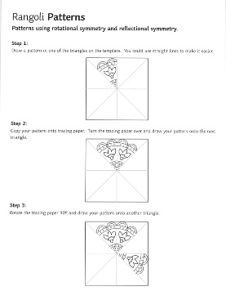  Rangoli Patterns – More information on the blog  Or check out Draw with Steve Harpster on youtube.  Or Art Club with Olaf Falafel on youtube.
Reading Activities:  - Make a timeline of important events in the text.  - Make a list of five titles that you think would make a better name for your text.  - Draw a map of the journey the main character took in the text.  - If finished reading your book – Write a review of the text.  - Write a letter to the author and tell why you did or didn’t like the text. | Using the strategies taught during Maths, calculate the sums below.  Choose a spice level or do them all! Show your working in your jotter.  Mild! Spicy! Hot!  15+89 258+625 4785+6251  85-46 952-268 67652-2541  54x9 521x9 3521x3  28÷3 354÷6 3412÷3  35÷2 124÷3 3589÷9  52+52 321+745 3658+6541  85-46 258-98 8602-4210  53x9 214x8 9544x8  65+93 838+525 10254+1458  154+152 845+658 95627+1245 | Sleep:  Complete the sleep cycle sheet in your pack, cut out the statements and stick them to the cycle.  You might have to ask a parent to help you or read about it online. | Science/Technology:  CARDBOARD CHAIR  This challenge focuses on the principles of design and structure. Can you design and build a chair from cardboard, that’s strong enough to support your weight?  Watch the video to find out more and see how Dyson engineers took on the challenge. https://www.jamesdysonfoundation.co.uk/resources
Reading: Log onto EPIC Reading using the class code: itm5966  EPIC is only accessible during school hours.  If using a tablet or phone, ensure you click ‘Have an account? Sign In’ at the bottom and not on ‘Parents’. Then, input your class code under ‘Student Log in.’  Read to the end of Soldier Bear:  - Create a detailed visualiser about the story.  - Complete the quiz on epic about the book. | Answer these maths questions:  1. 8 ping pong balls are packed in a tube. How many tubes can be filled  from 125 ping pong balls?  2. What name is given to an angle less than 90 degrees?  3. When rolling a die, what’s the probability of rolling an even number?  4. What is the first prime number after 14?  5. Subtract twenty-one from one hundred.  6. Change 8 ½ to an improper fraction.  7. What is 9 of 600?  10  8. Express ¾ as a percentage. ¾ x 100 = 75%  9. I had one pound. I bought two cartons of drink and got thirty  pence change. How much did each carton of drink cost?  10. How many £12 tickets can be bought with £187? | Mindfulness:  Do some mindfulness colouring. Think about how this can be used as a regulation strategy.  Listen to some mindfulness music on youtube. | Music:  Make a maraca – you can do this with a variety of material like maybe a box and rice.  See what happens to the sound when there is lots or not very much rice in? (or what very material you choose to use)
 |  | Teeth:  Look at the PowerPoint information in your pack and complete the sheets about teeth.  Think about the effect sugary drinks can have on your teeth.  Experiment: To see the effects sugary drinks have on your teeth put an egg in a cup of fizzy juice for a week – the results will be gross!!! | Learn a new skill:  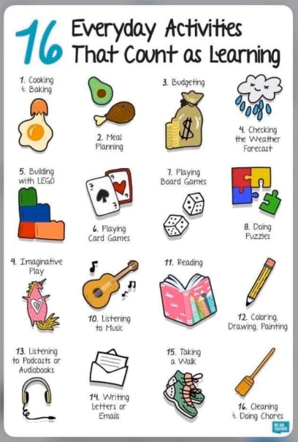
 |  | Outdoor Learning:  Do some of the Outdoor Art activities from the sheet in your pack. | Topic-  Complete some of the topic tasks in your pack or from the last pack.  Research some different climates and what types of animal can be found in each? What is special about this type of climate – is it hot, cold…?
Complete all the yearbook and assembly activities in your pack. – I need these sent to me ASAP!  Log onto study ladder, sumdog and edshed and complete some comprehension and spelling tasks  Spelling: words written on blog page. Practise these daily using your spelling grid. | Round these numbers to the nearest 10 and 100.  - 58 2. 651 3. 125 4. 654 5. 489  6. 6541 7. 2158 8. 648 9. 123 10. 2369  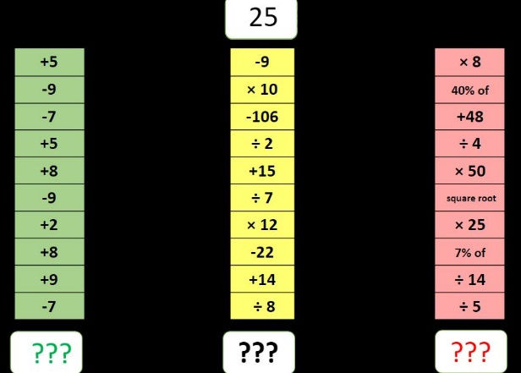 | 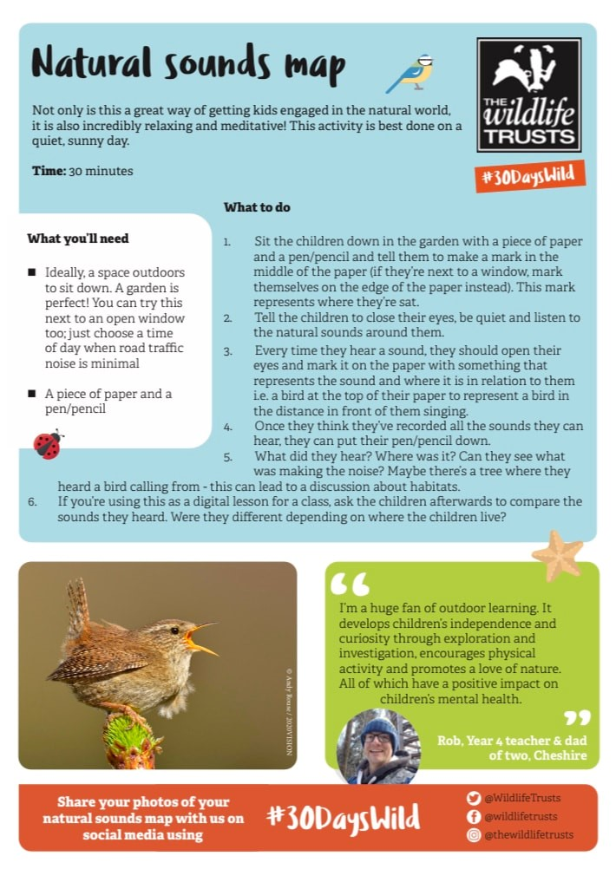 | Topic –  To learn some more cool stuff about our topic you could watch one of these programmes on youtube, netflix or iplayer.  - Blue Planet  - Deadly  - Our Planet  - Planet Earth  - There are also some cool programmes on disney + all about different animals.  - Steve Backshall is live on youtube and facebook every Wednesday to teach you about animals etc…  Let me know what you learn.
Writing:  Write an imaginative story. Use this image as a story starter:  What could be happening? Where is it? What emotions are your characters feeling? Describe your characters?  Here is an example of how you could start your story:  Astrid held out her hands. She was alone in the forest, and an eerie silence surrounded her. All she could hear was the faint buzz, like a bee settling down on a flower, coming from the thing she held so protectively in front of her.  Her hands were suddenly filled with a comforting warmth, as a silvery light pulsed from the object. A tingle ran down Astrid’s spine.  “It must be magic…” She muttered excitedly under her breath... “It must be!” | 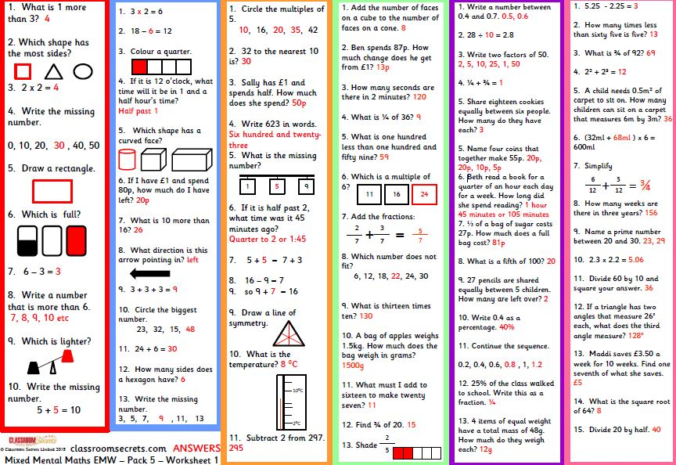 | Food:  Take part in some of the Farm to Fork activities included in your pack.  PE/Fun:  - The Heave Throw  - Standing Triple Jump  - Endurance Running  - Hurdling  Sheets in pack. | ICT:  Question - Think about the ways you use the Internet and note these down.  Do you visit websites? Do you message friends? Do you download music or post photographs?  All of what you have noted down is called your digital footprint. It is a trail of 'footprints' that you leave behind every time you go online.
Daily News and Disney Comprehension in pack. |  |  | REMEMBER TO FINISH AND SEND ALL YOUR YEARBOOK AND ASSEMBLY STUFF TO ME ASAP – WITHOUT IT THERE MIGHT NOT BE A YEARBOOK OR AND ASSEMBLY.

