Guide to accessing Glow email

1.Go on Glow website https://sts.platform.rmunify.com/account/signin/glow
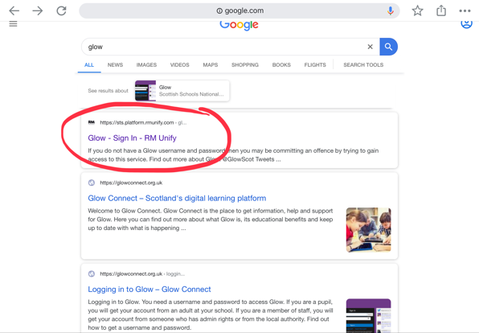
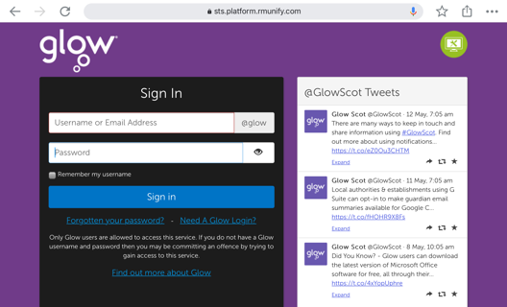
2. Enter login details (same as use for Teams)
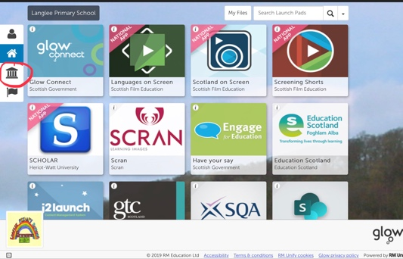
3. Select the Scottish Borders Council icon on the left (under home)

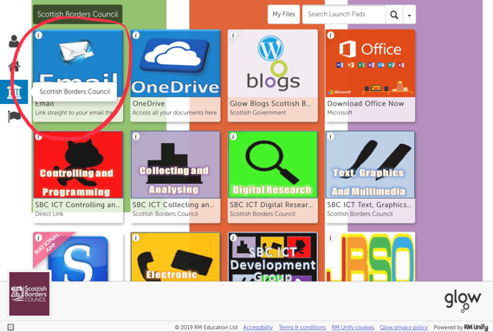
4. Select the email icon.

