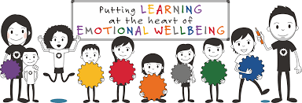
Langlee Primary School
Emotion Works – Parent Information

Emotion Works is a colourful education programme designed to help children learn emotional language, develop emotional understanding and manage feeling and behaviours.

At Langlee we use this programme throughout our school, from Nursery to Primary 7, to ensure our children are happy, ready to learn and build confidence and resilience.

About Emotion Works

Emotion Works is based on the ‘Cog Model’. It breaks the topic of emotion into 7 parts, but also shows how each of these cogs link together to help children and young people understand their emotions and how to express them in a healthy way.

Nursery

With our youngest children we focus on building and developing emotional language (orange cog – emotion words). We encourage children to think about other emotions; moving on from just ‘happy’ or ‘sad’.

P1-4
Moving into P1 we begin to introduce more cogs. From P1-4 we introduce and explore the 5 cog model; orange, red, yellow, green and blue cogs.
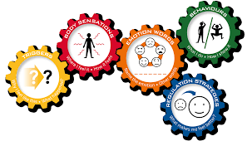

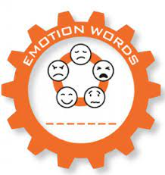

- Orange cog (emotion words) this cog focuses on exploring emotional language building on vocabulary explored in nursery.

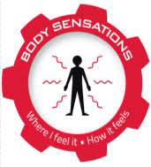

- Red cog (body sensations) encourages us to think about how the emotion makes us feel inside ie. Butterflies in our tummy, feeling hot, shaky or sweaty etc…

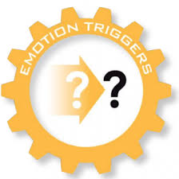
- Yellow cog (triggers) this cog teaches us to think about why we feel different emotions thinking about triggers and causes. We use stories, films, music, art and daily situations to discuss these.
- Green Cog (behaviours) this cog looks at what do we do to show how we are okay, and if not what could we do instead? We spend a lot of time learning and working on this cog as it is important to ensure our pupils are expressing their emotions in healthy and safe ways. It is also important that children are able to distinguish between the red and green cog.
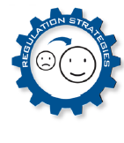
- Blue cog (regulation strategies) the blue cog is when we explore what strategies we could use to cheer up, calm down and make ourselves feel better. Different children will use different strategies. This may take some time to find what works for each child. Regulation strategies could be taking deep breaths, playing a card game, drawing etc…

P5-7

As the pupils move through second level (P5-7) they will build on their knowledge of the 5 Cog Model and introduce 2 new cogs for the 7 Cog Model.
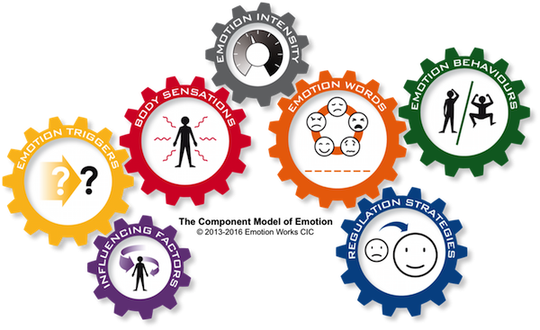

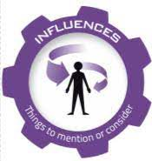

- Purple cog (influences) Exploring how are feelings, actions and behaviour can be influenced by others. We look at the wider context, thinking about if there is anything significant about the situation or the person involved.
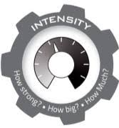
- Grey cog (intensity) this cog focuses on the intensity of our emotions. i.e. on a scale of 0-10 how happy are you? A little or a lot.

Emotion Works is a great tool to use both in school and at home, breaking emotions down into the different cogs can help us to understand how our are children are feeling, why they are feeling different emotions, discuss regulation strategies and more. As well as developing confidence, resilience and ensuring children are ready to learn.

