Curriculum Overview
Primary P3
Term 4 – April - June 2021

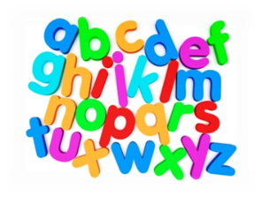  Language | - Phonics and spelling – revising all sounds and tricky words.  - Handwriting – linked to tricky words.  - Tools for Writing – understanding nouns, adjectives and verbs, using a variety of connectives and using punctuation appropriately.  - Writing – using planning formats to support our imaginative writing and looking at persuasive writing to create our own newspaper reports.  - Reading – understanding the difference between fact and opinion and group reading tasks.  - Talking and listening – recognising the difference between fact and opinion and learning presentation skills.
Mathematics | - Maths: Money – recognising coins, using money and consolidation of addition and subtraction through money.  - Maths: Time – telling the time and durations  - Number work: consolidation of place value  - Mental Maths: Basic Maths games / Sumdog
Health & Wellbeing | - PE with Mr Cocolin on a Wednesday afternoon – athletics.  - PE with Miss Wilson/Miss Thorpe on a Monday afternoon – athletics/games linked to IDL (topic).  - IDL link to responsibilities and being respectful and the importance of leading an active lifestyle.
Topic | - Toys – looking at difference sources, timelines and comparisons between modern life and life from a time in the past.
Modern Languages | - French – Ma famille. Talking about family and begin to develop an understanding of masculine and feminine.
Expressive Arts | Art, Dance and Music  - Link to Toys topic - sharing thoughts and feelings about artists, designers and music.
Technologies | - Link to Toys topic – learning simple instructions and using a coding programme to create sequences and code.
Additional | Homework:  - Please check Reading Records. Children to bring their reading bags in daily. Books will be taken in on a Friday to be quarantined over the weekend.  - Topic work to be completed over the Term.  - Continue to use Sumdog/Teach Your Monster to Read and Rockstars at home.

