Curriculum Overview
Primary P3
Term 3 – January to April 2021

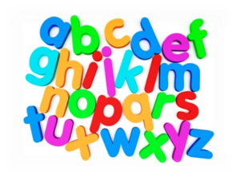  Language | - Phonics and spelling – revising all sounds and focusing on tricky words.  - Handwriting – linked to phonic sounds and tricky words.  - Writing – looking at Scots words and comic design, different types of poetry, note taking, simple instructional writing and creating short diary entries.  - Reading – children will have group reading 3 times a week. Focus on identifying the main points, sharing their opinions, answering questions about texts they read and reading with fluency.  - Talking and listening – watching topic PowerPoints and videos alongside Newsround to identify main points.
Mathematics | - Number work: Multiplication (groups of/repeated addition/arrays/2-,5-,10- and 3- and 4-times table).  - Number work: Consolidation of addition and subtraction and place value.  - Maths: Measurement – length and weight.  - Mental Maths: Basic Maths games / Sumdog
Health & Wellbeing | - PE timetable from Mr Cocolin will be found on Teams.  - Looking at ways that we can keep ourselves SAFE (first part of the SHINARRI wheel).
Topic | - Scottish Artists and Designers  - James and the Giant Peach

