Curriculum Overview
Primary P3
Term 2 - October to December 2020
If you have any questions please send a note in your child’s reading record and I will ring you to discuss your query at a convenient time after school.
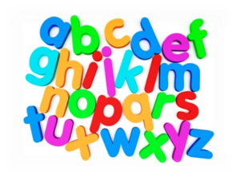  Language | - Phonics and spelling – revising all sounds.  - Handwriting – linked to alphabet and phonic sounds.  - Writing:  1. Grammar – Capital letters and full stops revision and sentence sequencing – joining two sentences together.  2. Imaginative space adventures and functional writing fact files about space exploration and a planet your child has researched.  - Reading –Children will have group reading 3 times a week. Please remember to have reading books in every day.  - Talking and listening – watching Space videos related to our topic. Discussing different World Festivals.
Mathematics | - Number work: Adding (numbers to 20, 50 and 100).  - Data Handling – graphs and surveys.  - Mental Maths – twice a week  - Basic Maths games
Social Studies | Space  - We will be learning about the planets in our solar system.  - Exploring the patterns of movement of the sun, Moon and Earth  - Learning about key important space explorations and the international space centre  - Research and discuss key Astronauts, their space explorations and activities.  World Festivals  - Exploring festivals and events that take place in November and December.
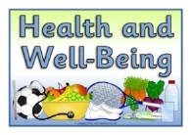  Health & Wellbeing | - PE in on a Monday with Mr Cocolin. Please make sure pupils come to school in their PE kit.  - Discussing emotional behaviours and develop strategies to self-regulate through behaviour matters stories and class discussions.
Expressive Arts | Art  - Exploring different art materials texture and form.  - Festivals and Christmas Craft  - Art is with Miss Stirling on a Thursday.
Modern Languages | French  - Revision of numbers to 30. #  - The weather and seasons, months of the year and days of the week.
RME | Religious and non-religious festivals and celebrations linked to the seasons:  - Including the origins of the months of the year  - Religious and non-religious festivals that fall in the months leading up to Christmas
Technologies | - Use of different Maths and Literacy based phonic games to enrich learning.  - Technology liked with Space Topic.
Additional | Homework:  - This term children have been asked to practise their reading 3 times a week.  - Topic work to be completed over the Term.  - Continue to use Sumdog at home.

