Curriculum Overview
Primary P3
Term 1 Aug- Oct 2020
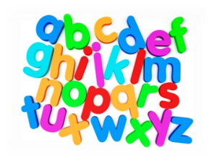  Language | - Phonics and spelling – revisit all sounds  - Writing -  1. Grammar - Sentence sequencing.  2. Retelling a story including a traditional tale, creating their own fairy tales, with a topic focus on castles.  - Reading - Working on their decoding, fluency and comprehension skills.  - Talking and listening – Newsround, listen to and answer questions on class novel, video clips linked to topic, numeracy, literacy and Health and Wellbeing.
Mathematics | - Mental maths and basic maths groups  - 2D and 3D shape and symmetry  - Number - numbers within 20, 100 and 1000, counting in 2s, 5s, 10s, odd and even numbers and revising number lines and number squares.
Social Studies | - Castles Topic (September to October) – we will be exploring lots who lives/d in a castle, what the purpose of a castle is, what they are made of and the key features, the role/job with key important people within a castle and designing a castle including different 3D shapes.
Health & Wellbeing | - PE – Monday with Mr Cocolin. Please could pupils come to school in their PE kit.  - Daily Mile  - Topic – The Colour Monster linked to Emotion Works and introducing the different cogs.
Expressive Arts | Art :  - Exploring different art materials.  - Line drawing and analytical drawing  - Colour mixing primary and secondary colours  Music:  - Listen to songs linked to number, times tables and French songs
Modern Languages | This term the children will continue to work on their French skills in their everyday routine. We will also be looking at:  - Colours  - Numbers to 30  - Feelings
Creativity Friday | - Looking at Art. Step-to-step instruction drawings and how to use line and textures in our drawings.
Technologies | - Use of different Maths and Literacy based phonic games to enrich learning  - Design and make a castle in a group using recycled cardboard boxes and a variety of art materials.
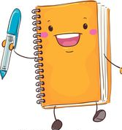  Additional | Homework:  This term children have been asked to practise their reading throughout the week.  Please make sure reading books are brought in everyday to class. Books will be collected and cleaned on Thursdays.  Homework activities will be on the Blog - http://www.langleeprimary.com/primary-3.html

