Curriculum Overview Primary 7 Date Jan-April
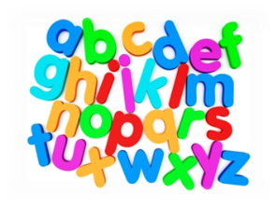  Language | - Writing – Creative and Imaginative writing continuing to consolidate our understanding of VCOP.  - Writing – linking writing with reading activities to write book reviews, blurbs then biographies.  - Reading – Developing vocabulary, reading comprehension skills, developing ideas and opinions from texts/research.  - Reading with fluency and expression aloud to a group.  - Speaking and listening –Class discussions, presentations and debates. Expressing opinions respectfully. Reciting poetry.  - The children will also take part in handwriting weekly.  - Spelling – working on spelling patterns through daily activities  - Some pupils also have an IDL account to develop literacy skills.
Mathematics | - Times tables (+Times Tables Rock Stars)  - Basic maths facts  - Mental maths tasks (+Sumdog)  - Multiplication and division written methods  - 3D shapes  - Consolidation of written addition and subtraction.  - Problem solving/word problems  - 2D shape, angle & symmetry
Topic | - Scots Language  - Democracy in Scotland  - Science – floating, forces, lifecycles and dissolving. Carryout practical experiments, making predictions and recording results.  - Art: Exploring Scottish artists  - ICT – internet safety  - ICT – developing IPad skills, learning about Microsoft Teams
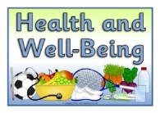  Health & Wellbeing | - Internet safety, cyber bullying and awareness of screen time.  - Emotion works  - Healthy eating and food hygiene.  - PE –Children will have PE on a Wednesday. Child should be prepared to take part in the lesson, wearing suitable clothing.  - Daily exercise suggestions (Joe Wicks, yoga & challenges)
Additional | Please check Teams for resources and weekly timetables.  Any questions please contact Miss Moffat via email at gw13moffatkirsty@glow.sch.uk

