P7 Curriculum Overview - October - December 2020
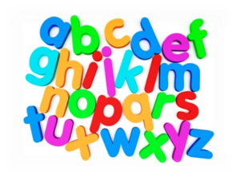  Language | - Reading for information - Skimming texts, using tools to check unknown words and highlighting evidence.  - Spelling – using a range of activities to improve understanding of spelling patterns, rules and phonics  - Short stories/ comprehension  - Reading aloud with expression and accuracy, moving on to reading and understanding higher level vocabulary  - Imaginative writing - building characters and setting.  - Diary Writing  - Focus on Connectives to lengthen sentences and add more detail.
Mathematics | - Decimals and money  - Multiplication (continuing all year)  - Written subtraction strategies  - Written multiplication strategies  - Mental maths strategies  - Word Problems
Health & Wellbeing | - PE  - Daily Mile  - Emotion Works  - Team building  - Internet Safety
Expressive Arts | - Concepts of art and Spanish artists (with Miss Stirling)  - Portraits  - Christmas crafts
Technologies | - Internet Safety  - Using ICT to find information  - Exploring IPad Apps – Pages & Power point  - Dictionary & Thesaurus.com
Topic  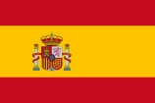 | - Spain
Additional | - Weekly spelling homework – complete 3 different activities  - Times Tables to practise  - Occasional maths homework tasks (worksheet)  - Reading homework (all groups have weekly reading homework)  - Pupils are encouraged to work on:  - Sumdog  - StudyLadder  - Times Tables Rock Stars  - IDL (if they have an IDL account).  - If you have any questions/concerns, please make an appointment with the office to speak to me.  Miss Moffat

