Curriculum Overview Primary 7 Date Jan- April 2021
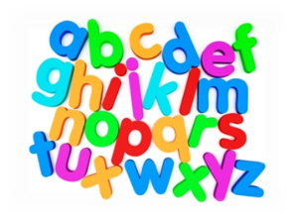  Language | - Writing – Creating texts; exploring the elements writers use in different genres and learning to create stories, poems and plays and persuasive arguments.  - Reading –for enjoyment and understanding of unfamiliar text. Learning to choose challenging text and justify the choices.  - Tools for reading – Learning to use a range of strategies and resources to help make the meaning of texts clear.  - Speaking and listening – Learning to explain choice of text and preferences. Be able to talk logically and clearly on their chosen text.  - Daily handwriting and spelling: recognising word patterns and using various spelling strategies.  - Handwriting will involve using linked script in all written tasks. (Tools for writing: I consider the impact of layout and presentation). There will also be daily touch-typing tasks.
Working with Mrs. Esmer | - We will be covering the Language as part of an ongoing intensive literacy support programme throughout our time at home to enhance challenge and performance within Langlee Primary School home learning experience. This continues to provide differentiated and consistent support during this time.

