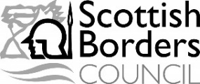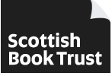

Dear Dad, Mum or carer
Free Bookbug Primary 1 Family Bag activity sessions
Starting school is an exciting and challenging time for your child and they may be feeling this even more after the changes to their lives from Covid-19. Now more than ever, your support and encouragement at home makes a real difference to their learning. That’s why we’re letting you know about a free bag of books and activities your child will soon receive from Bookbug, to help support their reading, writing and counting skills.
We are offering 3 information session on Microsoft Teams to explore and offer activities for you to do with your child based on the books in the bag. We recommend you attend all the sessions.
Tuesday 23rd Nov 1.30-2.30pm
Tuesday 30th Nov 1.30 – 2.30pm
Tuesday 7th Dec1.30- 2.30pm
Outdoor session tbc
These session will be delivered by Amanda Dempsey and Becca Childs

To book a place please email:
BChilds@scotborders.gov.uk or Amanda.Dempsey@scotborders.gov.uk
Or call Amanda on – 07776116936

Closing date for bookings: Friday 19th Nov 21
Kind regards
Amanda & Becca

