Exercise | Teaching points | Adaptation/variation | Picture | Online video support
Jumping jacks | Stand upright with your legs together, arms at your sides.  Bend your knees slightly, and jump into the air.  As you jump, spread your legs to be about shoulder-width apart. Stretch your arms out and over your head.  Jump back to starting position.  Repeat. | Lateral step after starting position.  Squad jumps/after starting position add a squad. | 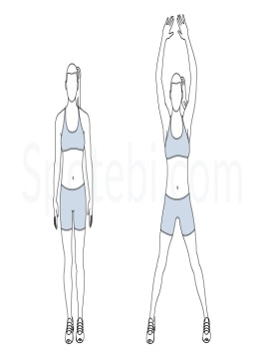 | https://www.nytimes.com/guides/well/activity/how-to-do-a-jumping-jack
Kneading push ups | - Straightforward and to the point. Just be sure your hands are in line with your pectorals and your booty isn’t arced in the air. If you want to make it harder, try for push–up claps, diamond push-ups, or “Y” wide push-ups. | Knee straight on toes press ups for better results |  | https://www.youtube.com/watch?v=_l3ySVKYVJ8
Crunches | - Lie on your back with your knees bent and feet flat on the floor, hip-width apart.  - Place your hands behind your head so your thumbs are behind your ears.  Don’t lace your fingers together.  - Hold your elbows out to the sides but rounded slightly in.  - Tilt your chin slightly, leaving a few inches of space between your chin and your chest.  - Gently pull your abdominals inward.  - Curl up and forward so that your head, neck, and shoulder blades lift off the floor.  - Hold for a moment at the top of the movement and then lower slowly back do | Another classic. Feel free to tuck your toes under the sofa or coffee table if you need a bit of support, or, ask your parents to hold your feet .Or perform a setups by flexing your hip towards even more. | 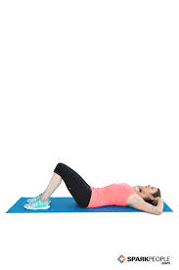 | https://www.youtube.com/watch?v=M6yAoJJQvGY
Flutter Kicks | - Lift your legs 4 to 6 inches off the floor. Squeeze your abs to keep your back from overarching. Keep your legs straight as you rhythmically raise one leg higher, then switch. Move in a fluttering, up and down motion. | Use scissor kicks for better results | 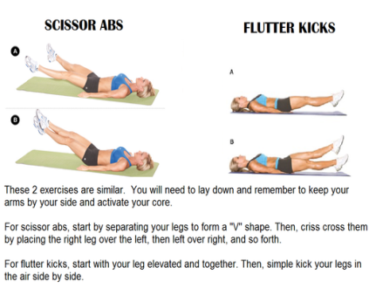 | https://www.youtube.com/watch?v=BlJQtdcCzeA
Leg raises | - Lie on your back, legs straight and together.  - Keep your legs straight and lift them all the way up to the ceiling until your butt comes off the floor.  - Slowly lower your legs back down till they're just above the floor. Hold for a moment.  - Raise your legs back up. Repeat | Increase or decrease the degree angle during lift. | 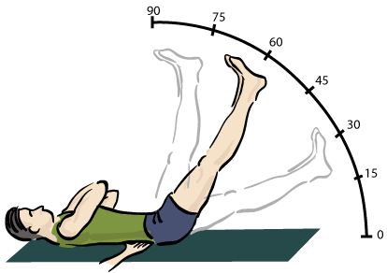 | https://www.nytimes.com/guides/well/activity/how-to-do-leg-raises
Triceps dips | - Slide your butt off the front of the bench with your legs extended out in front of you. Straighten your arms, keeping a little bend in your elbows to keep tension on your triceps and off your elbow joints. Slowly bend your elbows to lower your body toward the floor until your elbows are at about a 90-degree angle. | Use a chair or a bench or work over the stairs. | 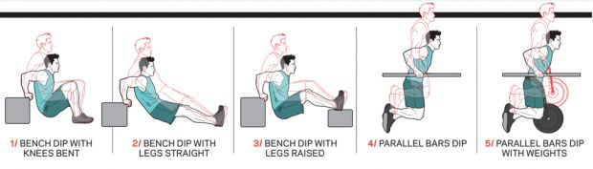 | https://www.youtube.com/watch?v=dl8_opV0A0Y
Frog jumps | - Face front, keep your core engaged and your shoulders back. Point your knees in the same direction as your feet and squat down as low as you can without letting your knees go past your toes. Sit on your heels and jump with your arms back. Land softly on your toes and exhale as you squat. | Swap over for burpees adding a press up for each repetition. | 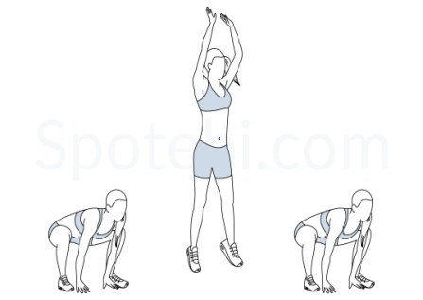 | https://www.youtube.com/watch?v=KfoXOxUgENE
Heel touch | - Step 1: Lay down with your back on the ground and your knees bent and pointed towards the ceiling.Step 2: With your arms on your side raise your shoulders slightly off the ground.Step 3: Using your abs rotate your right hand down to your right foot and then back up.Step 4: Then do the same thing with your left hand.Step 5: Alternate back and forth for the desired amount of repetition | Non. | Please check the video | https://www.exercise.com/exercises/heel-touch
High knees | - Stand up straight and place your feet about hip-width apart.Place your hands palms down facing the floor, hovering just above your belly button. Quickly drive your right knee up to meet your right hand, bring the same leg back to the ground immediately bring the left knee coming up to meet your left hand. | You may jump and bring your knees up to chest in same time . | 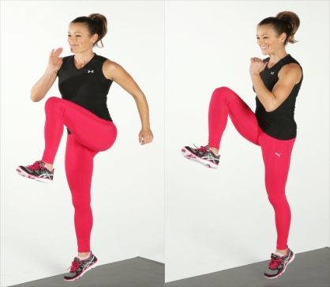 | https://www.youtube.com/watch?v=D0GwAezTvtg

